Bluetooth based android chat app

A project report submitted to

Department of Information and Communication Technology

Manipal Institute of Technology

Manipal

Submitted by

Sarthak Shastri,190911216

Aman Priyashu, 190911164

Sai Sravan Medicherla, 190911180

BTECH (IT-Batch A2) –VI SEMESTER, A SECTION

**ACKNOWLEDGEMENTS**

We would like to thank the Department of Information and Communication Technology for giving us the opportunity to work on a project to help in our understanding of development of Android applications . We would like to thank our professors, Dr.Tribikram Pradhan and Dr.Sameena Begum Pathan for guiding us through this project and our lab work of Advanced Technologies Lab. These learnings have helped us develop our application and make it robust.

**Table of contents**

1. PROBLEM STATEMENT…………………………………………....01
2. ABSTRACT…………………………………………………………..02
3. INTRODUCTION…………………………………………………….03
4. OBJECTIVE…………………………………………………………..04
5. PROBLEM DEFINTITION…………………………………………..05
6. DESIGN METHODOLOGY…………………………………………06
7. RESULT……………………………………………………..………..07
8. CONCLUSION & FUTURE WORK………………………..……….08
9. REFERENCES………………………………………………………..09

**1.PROBLEM STATEMENT**

Developing an android application to perform peer to peer text and image chat between two devices over Bluetooth.

**2.ABSTRACT**

Bluetooth is a wireless technology standard for exchanging data over short distances (using short-wavelength UHF radio waves in the ISM band from 2.4 to 2.485 GHz) from fixed and mobile devices and building personal area networks (PANs). Invented by telecom vendor Ericsson in 1994, it was originally conceived as a wireless alternative to RS-232 data cables. It can connect several devices, overcoming problems of synchronization. As part of our project we use Bluetooth to connect between two devices and for sharing messages and images between the devices. We perform this by creating a Local Area Network(LAN) over Bluetooth. Android has in built support for Bluetooth operation in devices, this allows us to develop applications that can send data over Bluetooth. This app is useful in places where we network problems. There are many scenarios such as when travelling by airplane, camping, trains etc. For example, sometimes when flying by airplane we get seats one row ahead or behind our friends or family. In that case it is very difficult to communicate with them without disturbing the others sitting beside us. This is the ideal scenario in which our application would make your lives much easier allowing you to text them without internet. The other use would be when we wish to transfer files without internet such as sharing photos or music while camping in the wild. This application provides a smooth and seamless user experience, allowing users to share music and images without having to navigate through the default Bluetooth options to transfer files.

**3.INTRODUCTION**

Bluetooth is a wireless technology standard for exchanging data over short distances (using short-wavelength UHF radio waves in the ISM band from 2.4 to 2.485 GHz) from fixed and mobile devices and building personal area networks (PANs). Invented by telecom vendor Ericsson in 1994, it was originally conceived as a wireless alternative to RS-232 data cables. It can connect several devices, overcoming problems of synchronization. As part of our project submission for advanced technology lab, we developed an android application to perform peer to peer chat between two devices over Bluetooth without the requirement of internet. To develop this app we Bluetooth adapter API present in android to build our application. We also ensure the application checks for Bluetooth and location permissions each time application is launched. The application uses input and output stream to transmit data between devices. It has a very simple and easy to use interface with an auto connect feature present allowing you to connect to another device nearby without having to explicitly select the device. The application allows you to send and receive text and images. This app is useful in places where we network problems. There are many scenarios such as when travelling by airplane, camping, trains etc. For example, sometimes when flying by airplane we get seats one row ahead or behind our friends or family. In that case it is very difficult to communicate with them without disturbing the others sitting beside us. This is the ideal scenario in which our application would make your lives much easier allowing you to text them without internet. The other use would be when we wish to transfer files without internet such as sharing photos or music while camping in the wild. This application provides a smooth and seamless user experience, allowing users to share music and images without having to navigate through the default Bluetooth options to transfer files.

**4.Objective**

* Transmit text between 2 devices over Bluetooth
* Transmit images between 2 devices over Bluetooth
* Connect seamlessly between 2 devices
* Option to change chat name
* Pair device automatically upon detecting device as using the application

**5.PROBLEM DEFINITION**

When we are travelling by flight or train, there is no phone connectivity in most cases. Sometimes while getting our seat assigned, it is one or two rows ahead or behind others from our group. In this scenario it becomes difficult to communicate between each other without disturbing the other passengers sitting nearby. The chat application helps to solve this problem by allowing them to communicate with each other without having to disturb any of the other passengers. It allows for seamless communication between the two devices using the application.

Another scenario is when we go on camping trips to remote areas. Most of the times these areas don’t have access to mobile phone connectivity, making it difficult to share images or music between each other. In this case when playing music on a shared speaker they would have to constantly to reconnect between different devices to allow everyone to play their music. Using the app they can send the music across at ease using the fluid and smooth user interface.

**6.DESIGN METHODOLOGY**

6.1. Hardware Requirements:

* Android Mobile
* Bluetooth Adapter
* GPS adapter

6.2. Software Requirements:

* Android 6 or above

6.3. Flow Chart

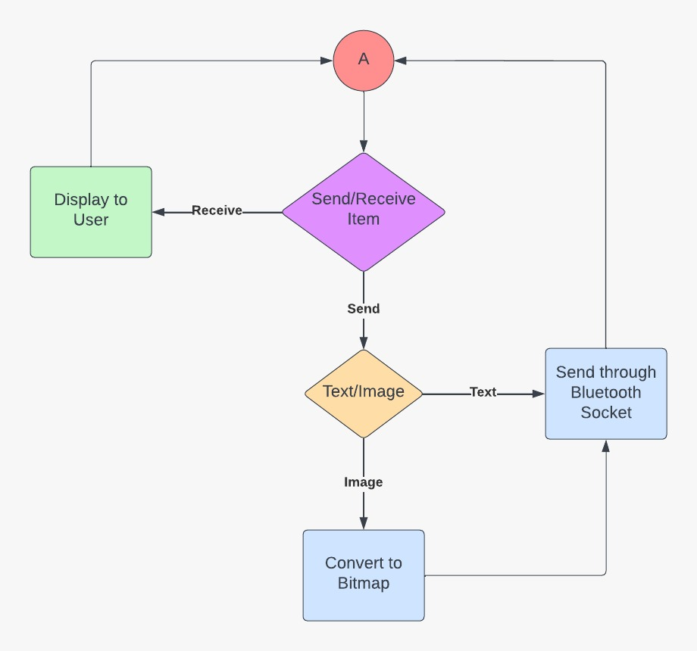

6.4 Use Case Diagram

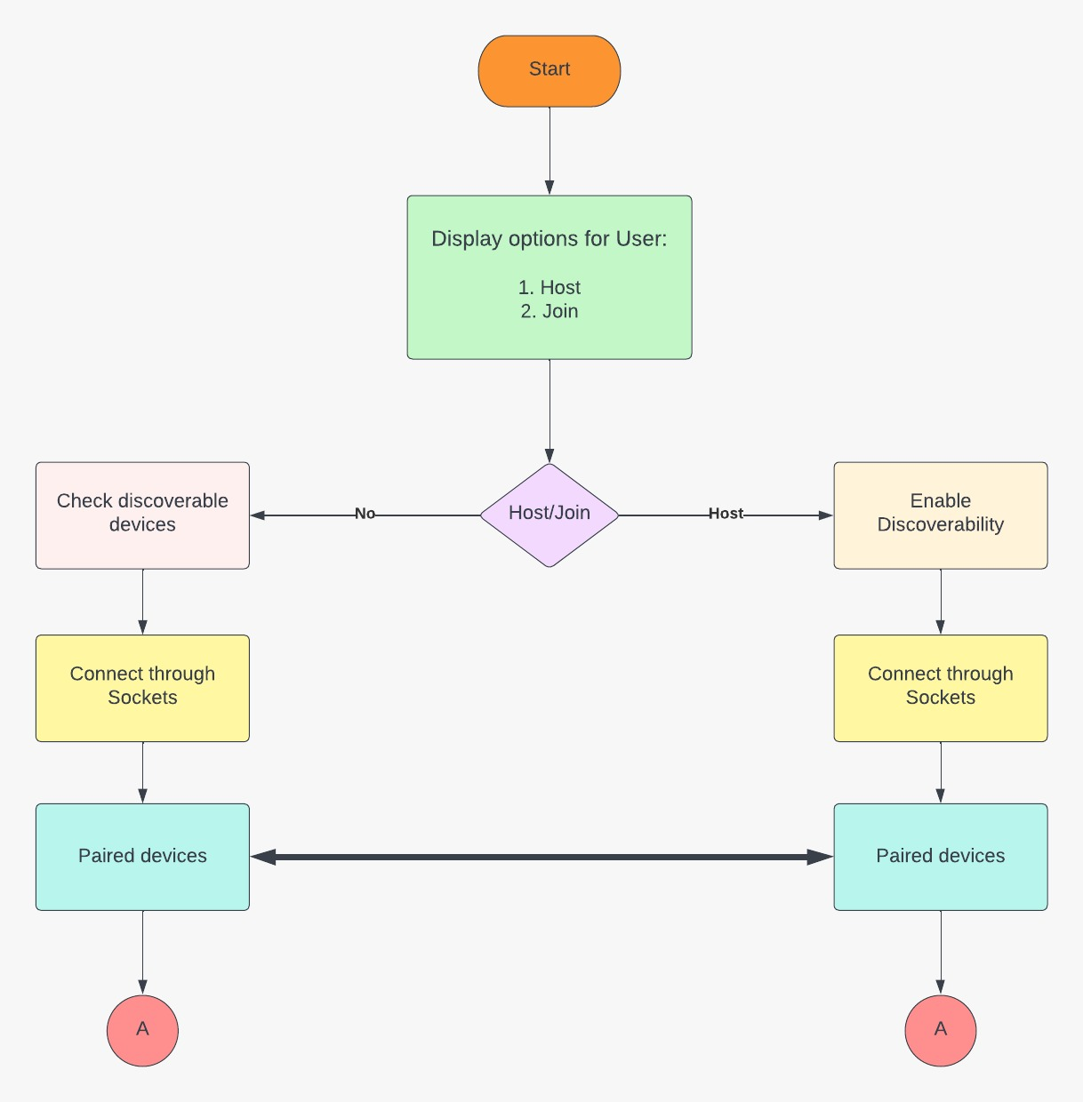

6.5. Class Diagram

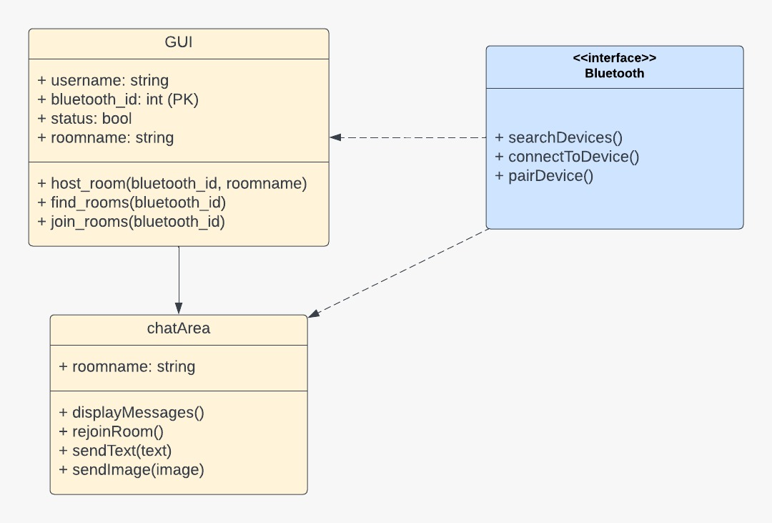

**7.RESULT AND DISCUSSION**

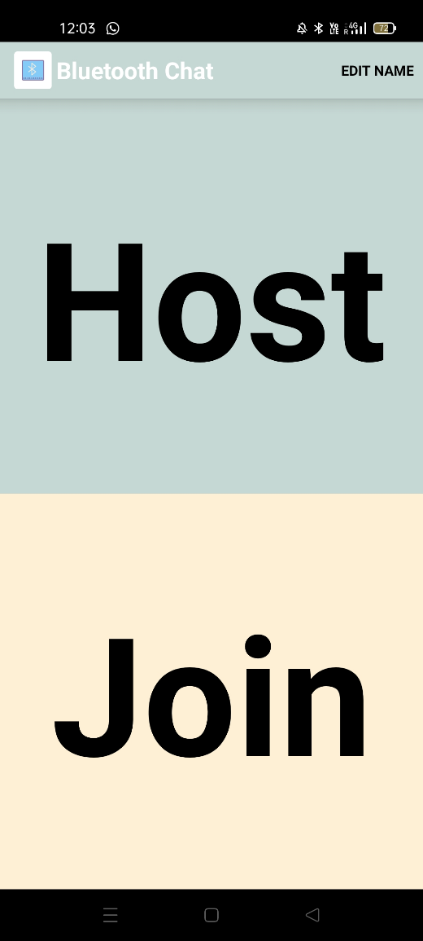 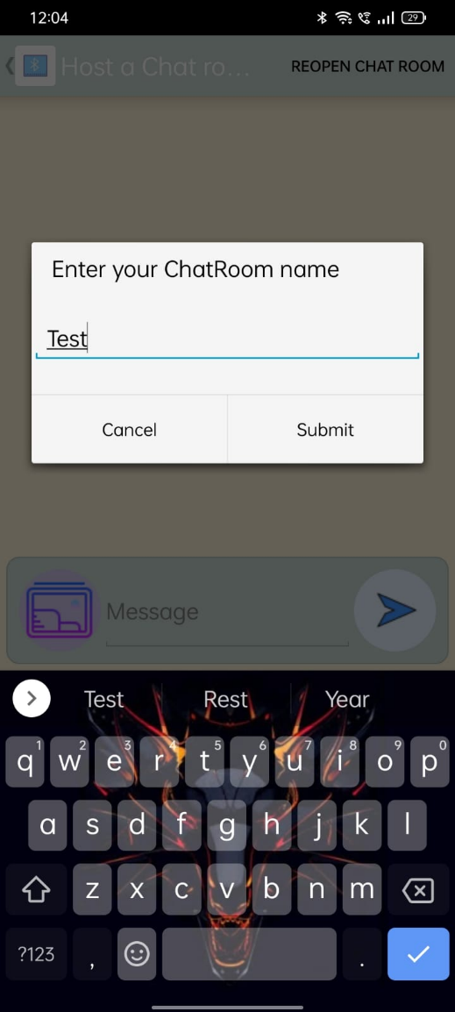

**Figure 1:** Homepage Activity **Figure 2:** Host Activity

In figure 1 the user can view the homepage which gives the user the option to host a chat room or join another user’s chat room.

In figure 2 the user creates his chatroom with a custom name which allows other users to join the chatroom for 300 seconds.

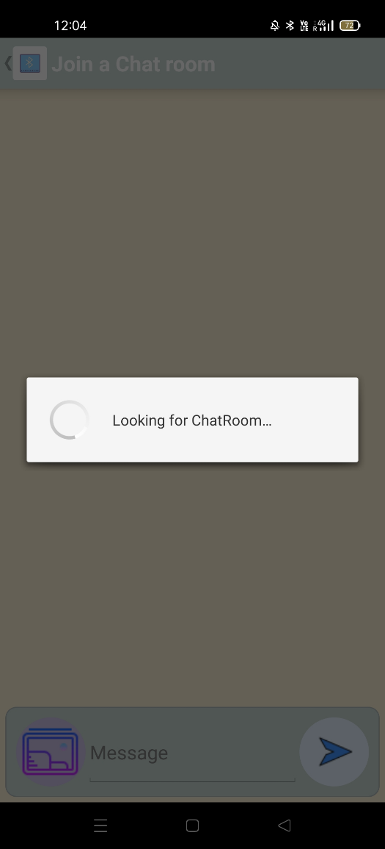 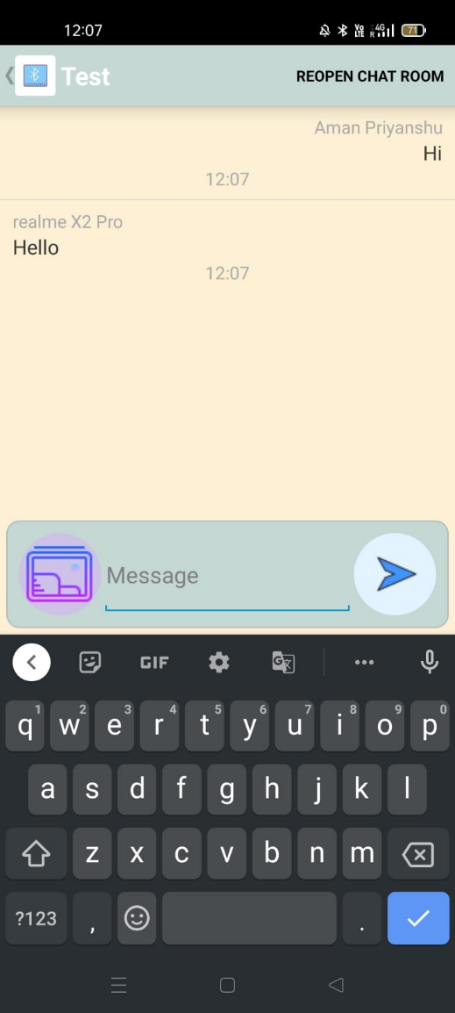

**Figure 3:** Join Activity **Figure 4:** Text Messages

In figure 3 the user on another device upon pressing the join button starts looking for a device with an open bluetooth connection and requests to pair. Upon pairing a connected to user toast message will show up confirming the connection between the two devices.

In figure 4 the two devices exchange text messages between each other which can be identified by the user id and each message is time stamped as well.

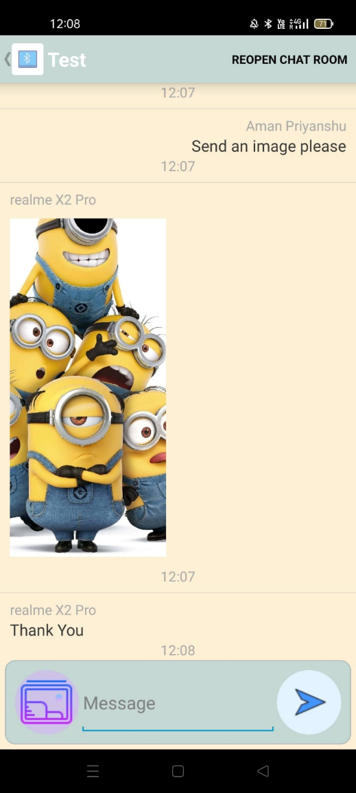 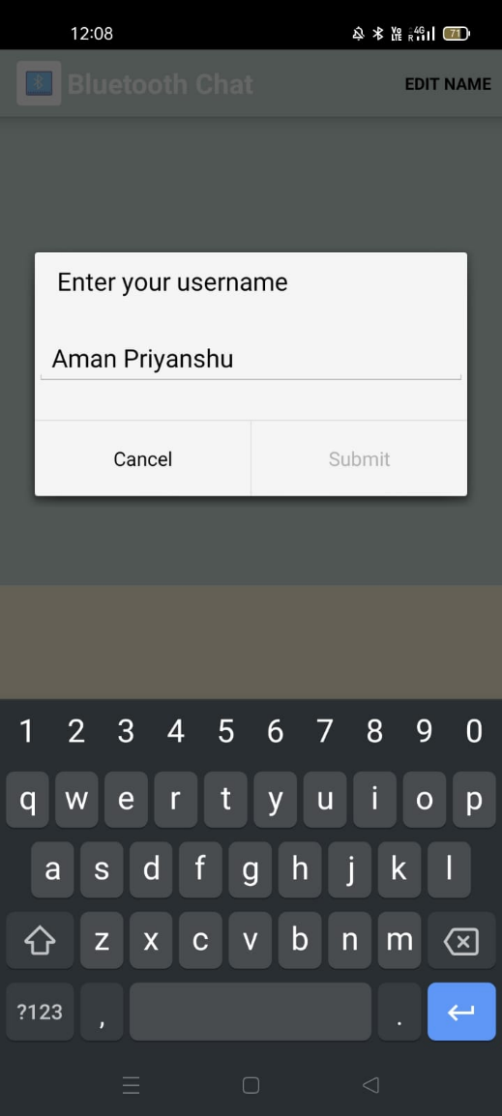

**Figure 5:** Image Message **Figure 6:** Rename Option

In figure 5 the user sends a image as message which is received by the other connected device

In figure 6 the user has an option to rename his device as he wishes. This device name is used as the user id when it sends messages

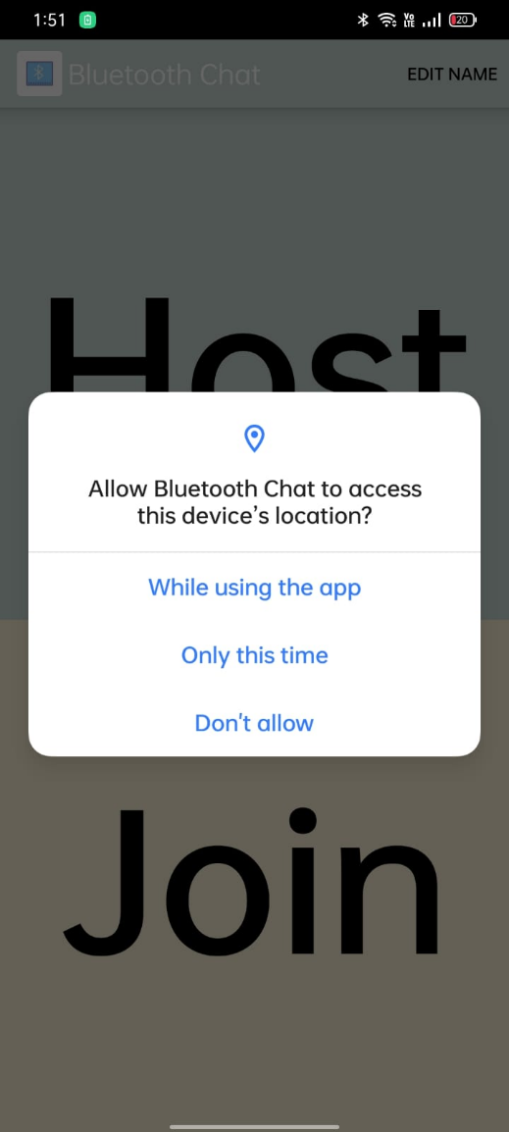 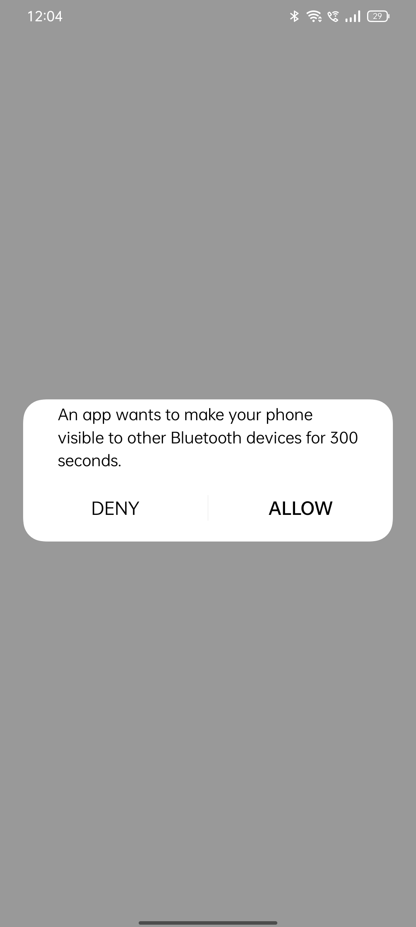

**Figure 7:**Runtime Permissions **Figure 8:** Reopen Chatroom

In figure 7 upon launch the user is requested to provide access to location services and storage in a cascading format one after the other. Location access is needed in order to implement the auto pair option in devices running versions greater than android 7.

In figure 8 upon completion of 300s the auto pair option is turned off and chatroom is closed. Upon clicking reopen chatroom button on top right part of the screen the user can reopen the chatroom and allow another device to connect for 300s.

**8.CONCLUSION & FUTURE WORK**

The application allows for a smooth and seamless communication between two devices. It allows images to be transferred over Bluetooth by compressing the images over bitmap. The application also has the auto pair feature present which allows for two unpaired devices trying to join a chat room to receive auto pair request and immediately begin chatting. The application can modify your Bluetooth device name as well to change your username while chatting. The development of this application allowed us to implement socket programming that we had learnt previously and integrate it with android.

Future work:

* Smoother connection process in areas with strong interference by allowing direct pairing
* Option to view chat history
* Progress Bar when sending image or video across
* Option to delete messages after sending

**9.REFERENCES**

* <http://www.devexchanges.info/2016/10/simple-bluetooth-chat-application-in.html>
* <https://www.tabnine.com/code/java/classes/android.bluetooth.BluetoothSocket>
* <https://dribbble.com/shots/17418513-Chatdong-Chatting-Mobile-App/attachments/12546671?mode=media>
* <https://riptutorial.com/android/example/23932/multiple-runtime-permissions-from-same-permission-groups>
* <https://kamrana.wordpress.com/2012/05/12/sending-images-over-bluetooth-in-android/>
* <https://www.tutorialspoint.com/android/android_bluetooth.htm>